Course Name | ITD 2343 – Object Oriented Programming with C#
Instructor | Mark L. Pranger
Student Name | Lauren Lashley
Due date | January 18, 2026
Grade | <grade earned here>
Grading Comments | <instructor comments here>

Week 2 – Programming Lab

3 screenshots of the build in progress:
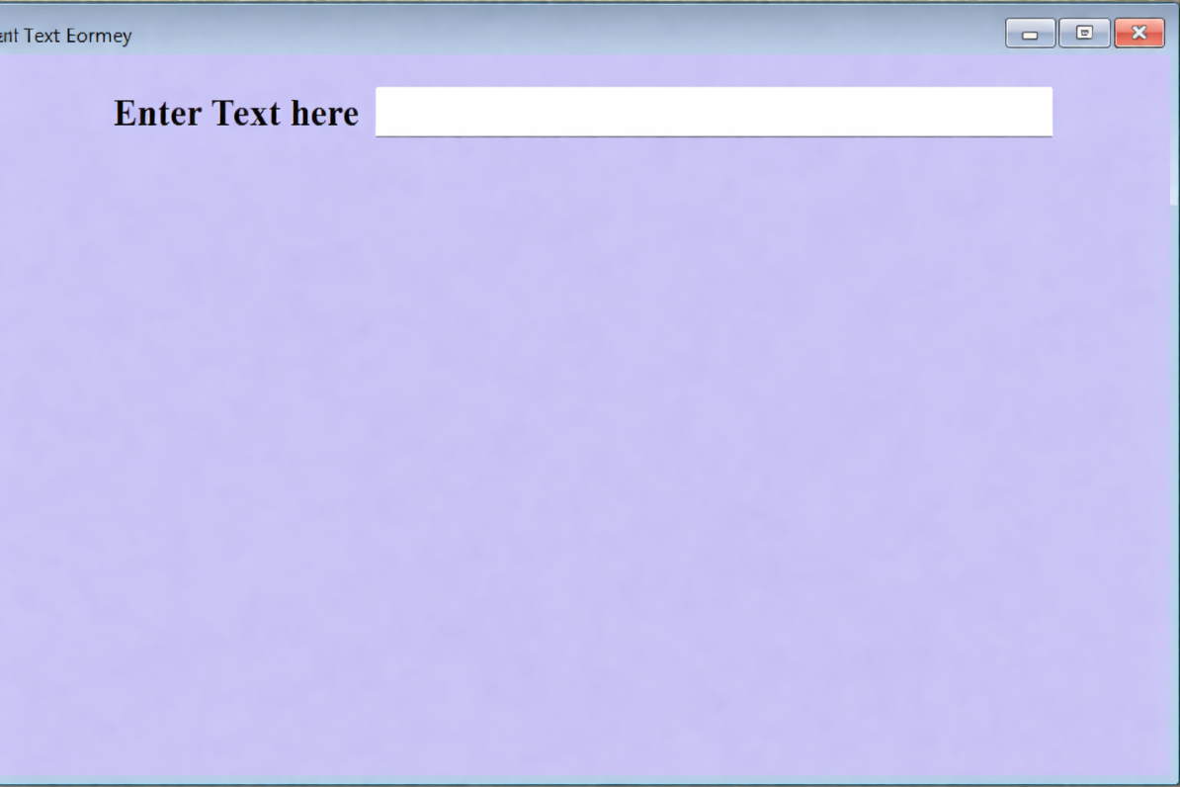
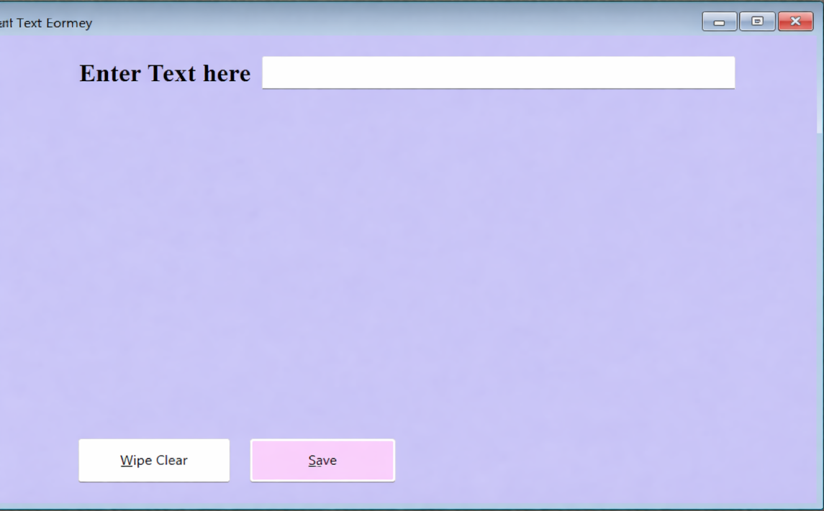

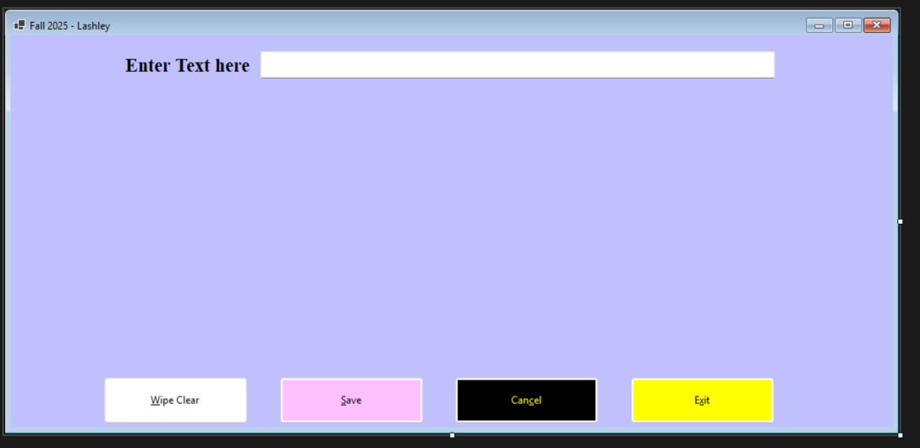

3 Screenshots of the properties as I was going:
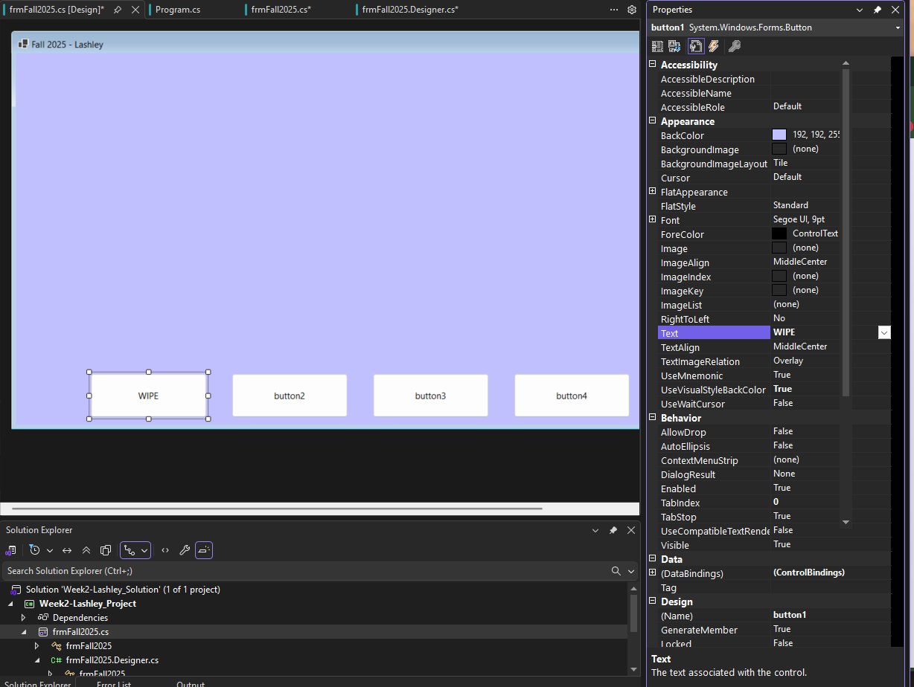
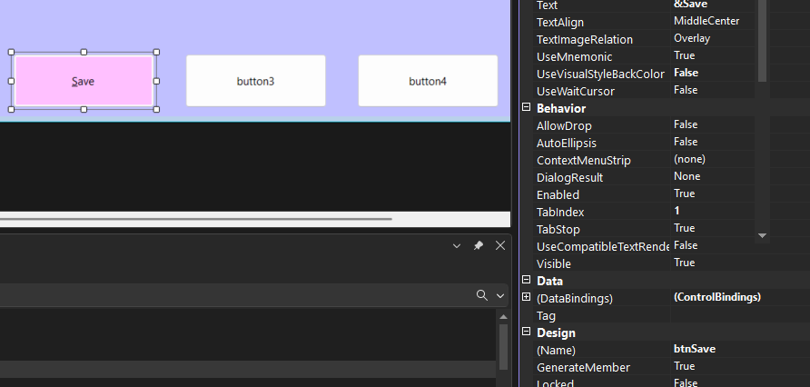
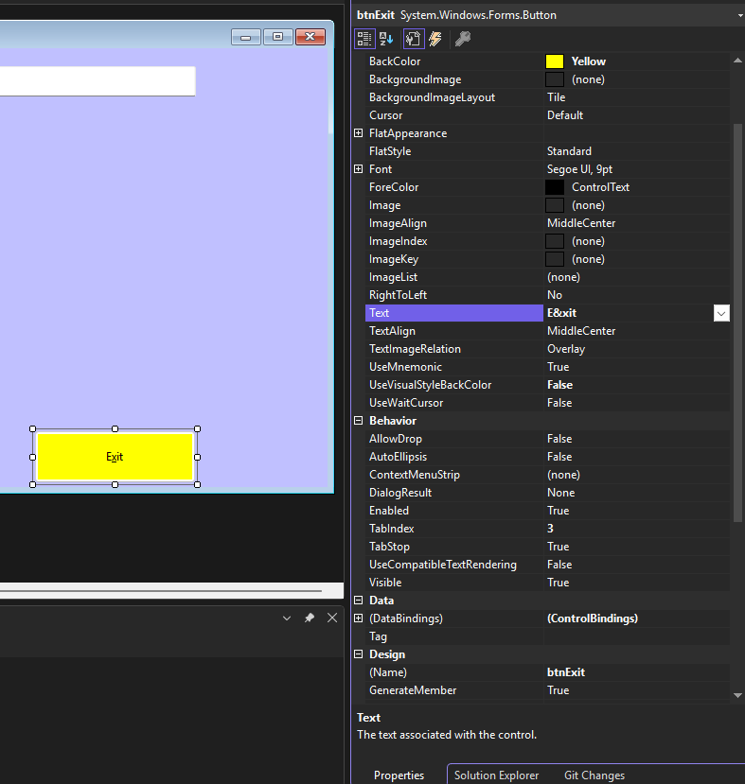

Screenshots of the btn_click logic:
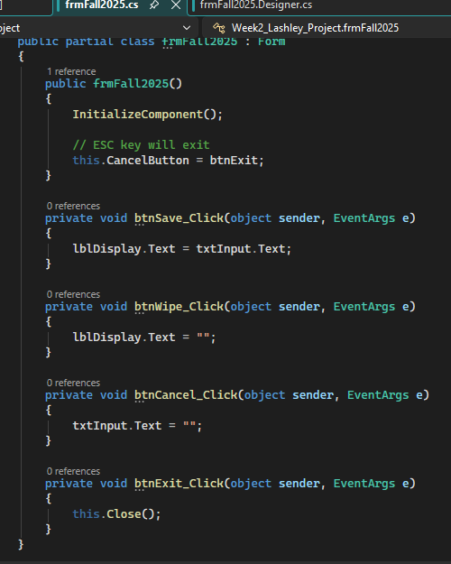

Run the application in debug mode:
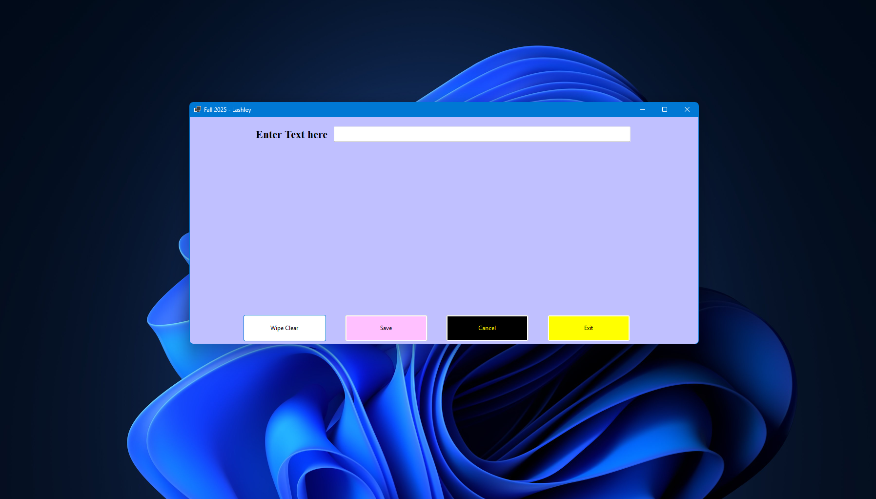

Screenshot of type something into the textbox, click the save button and show in a screen shot that the text is copied into the label correctly:
